WEEK-1 ASSINGMENT CONGNIZANT
Design Patterns:-
EXERCISE-1: : Implementing the Singleton Pattern

->Create a New C# Project

->Define a Singleton Class
->Test the Singleton Implementation
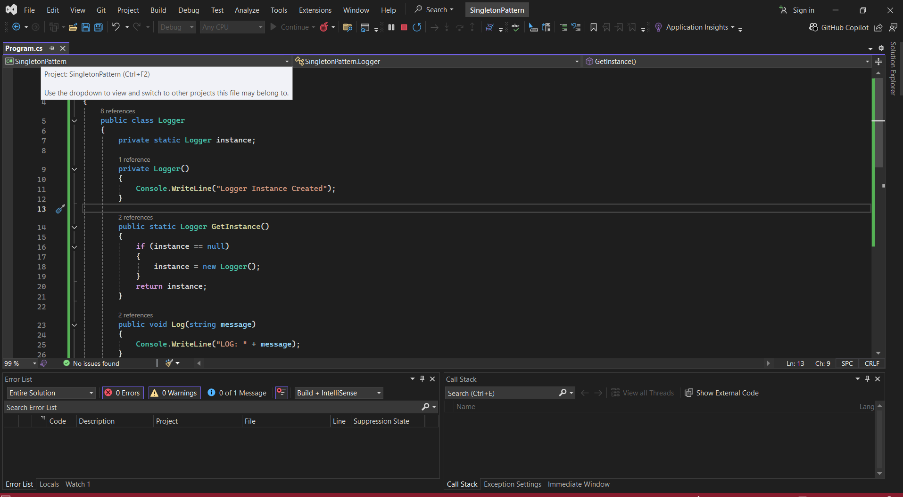
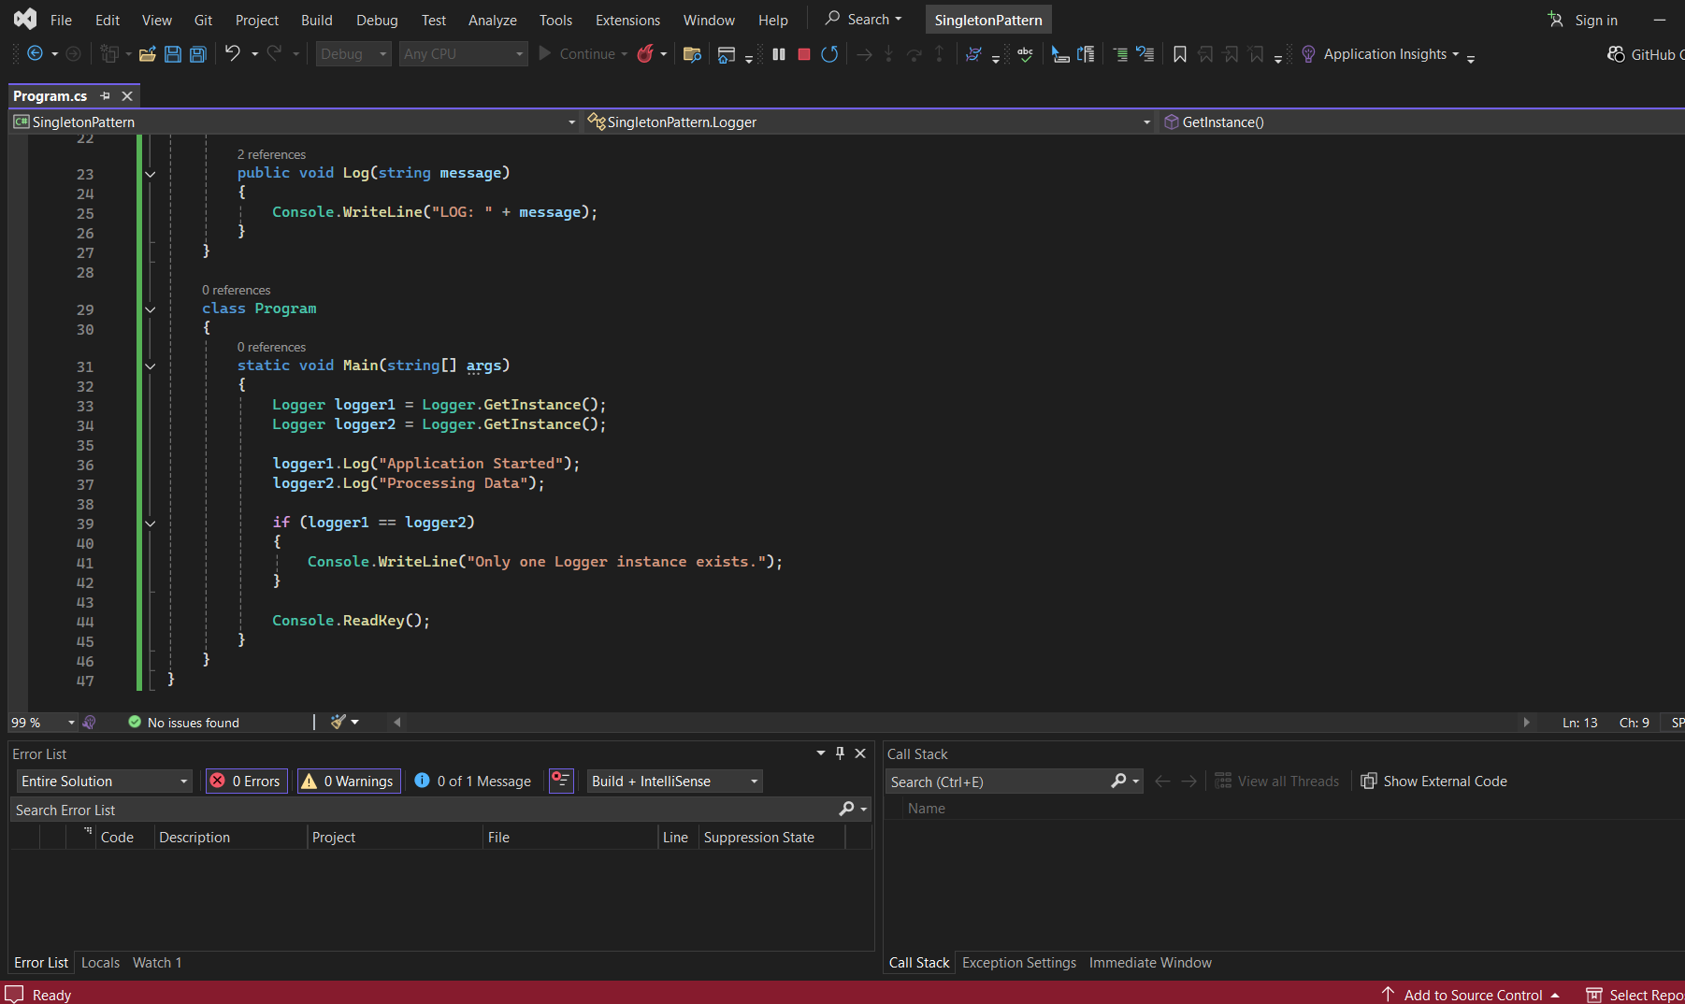

OUTPUT:
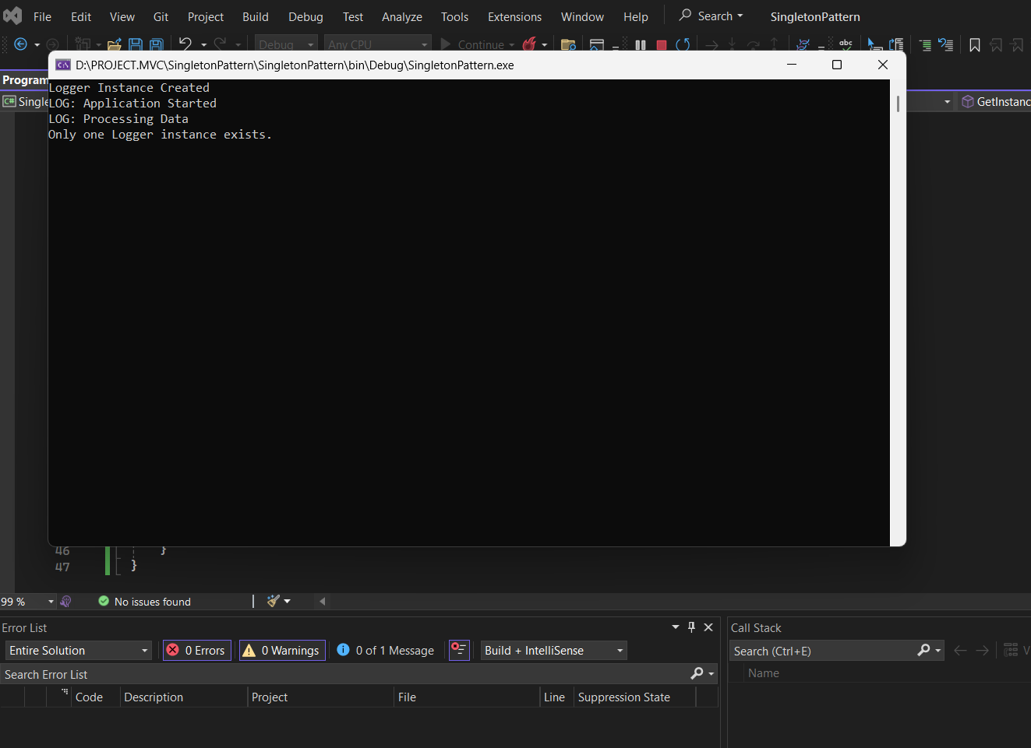

EXERCISE-2: Implementing the Factory Method Pattern
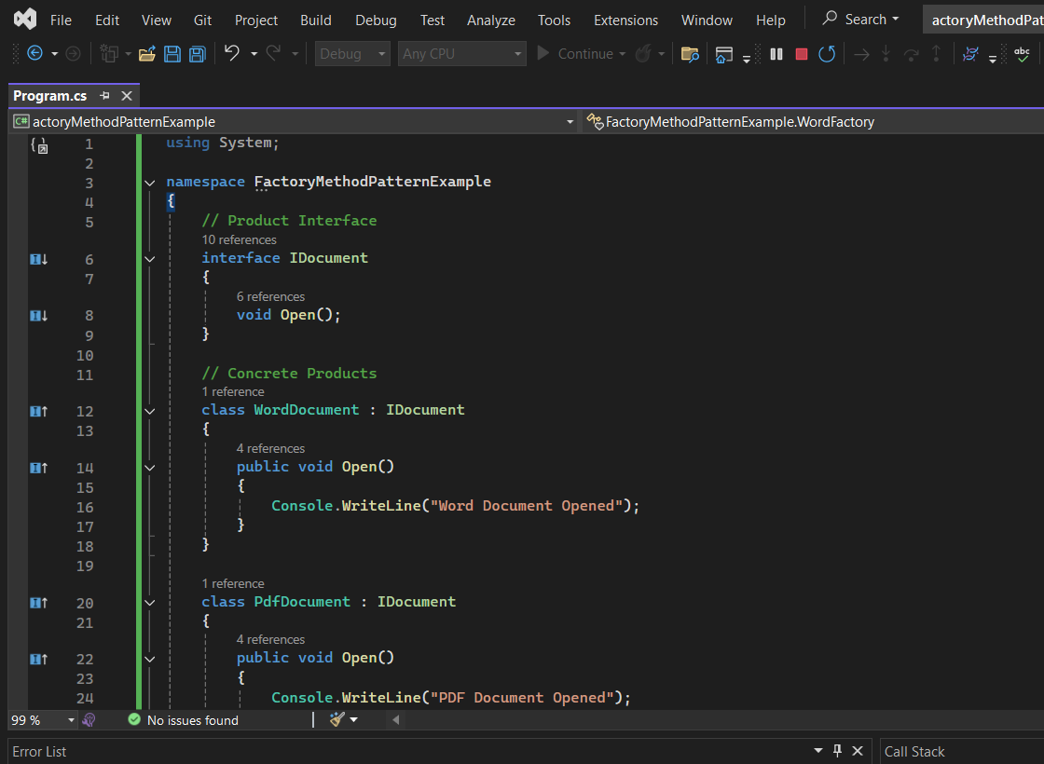
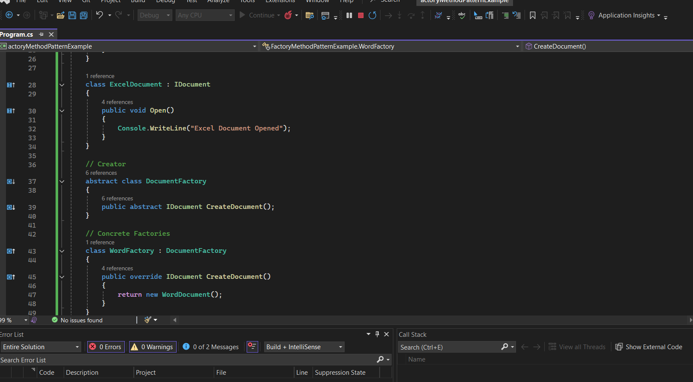
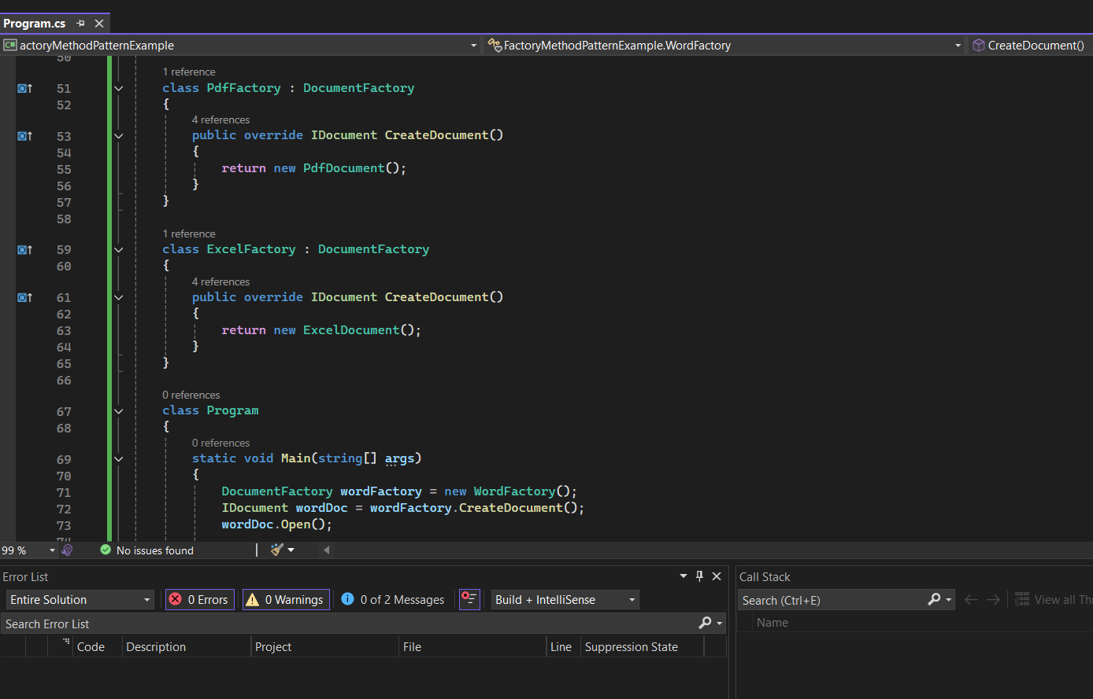
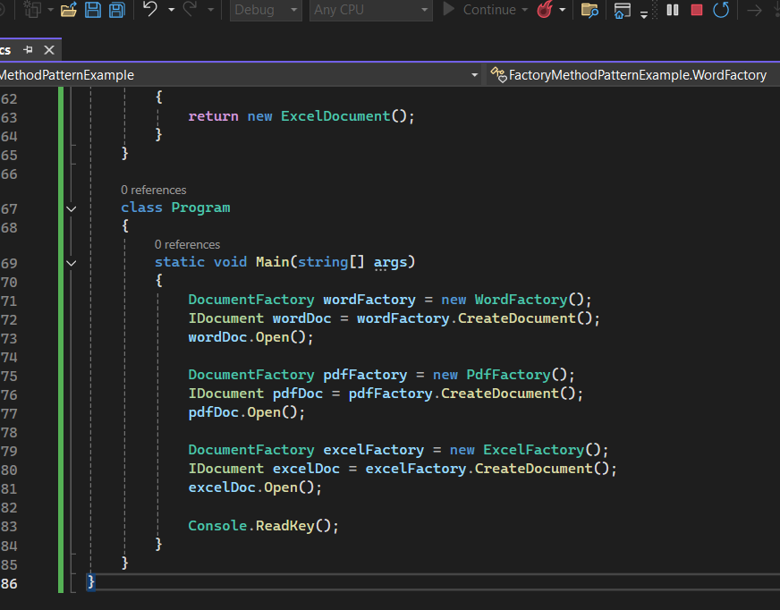

OUTPUT:
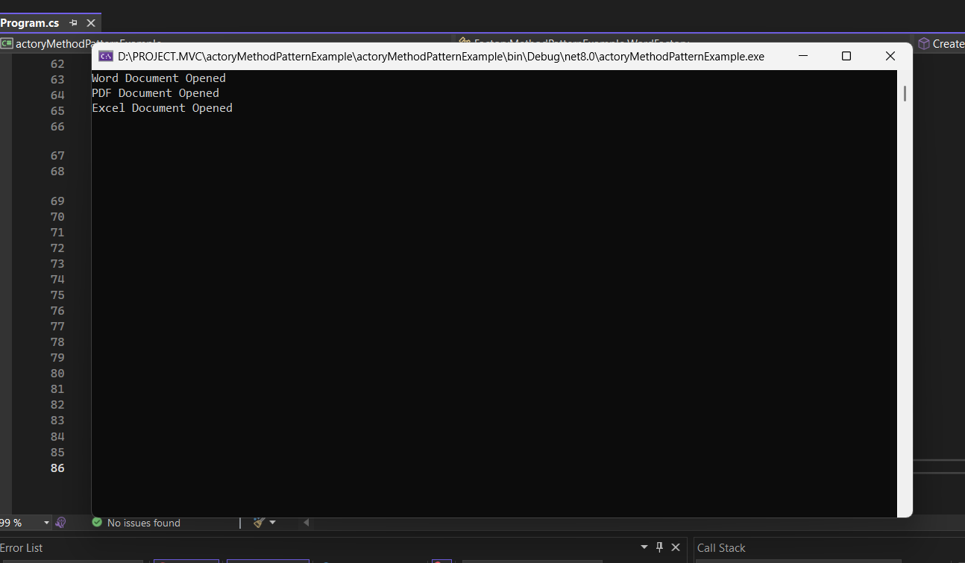

Data Structures & Algorithms
EXERCISE-2: E-commerce Platform Search Function
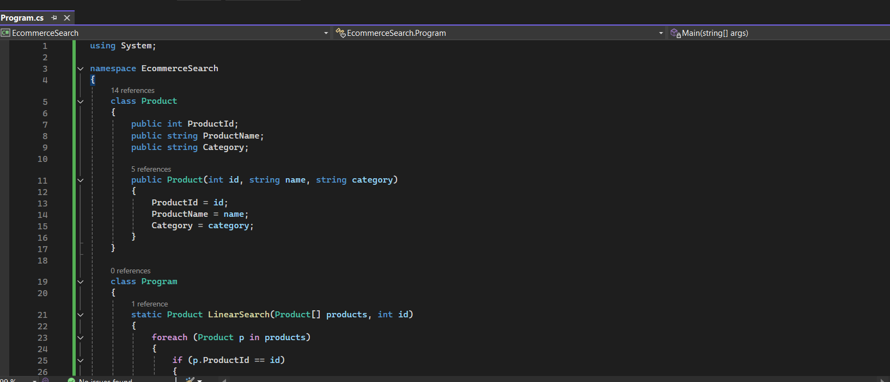
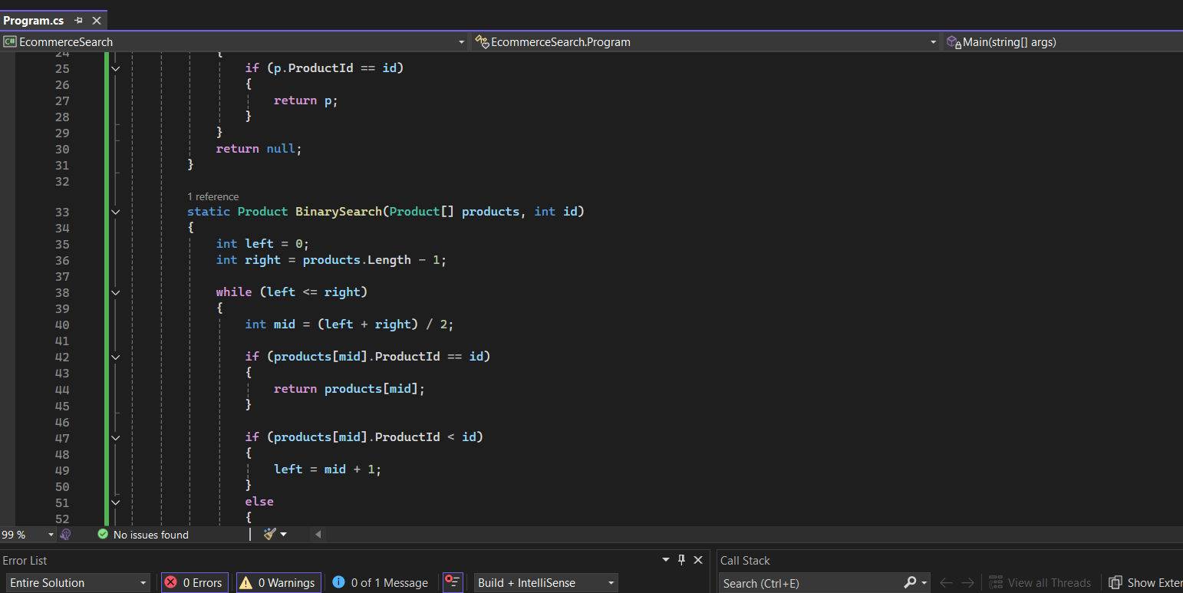
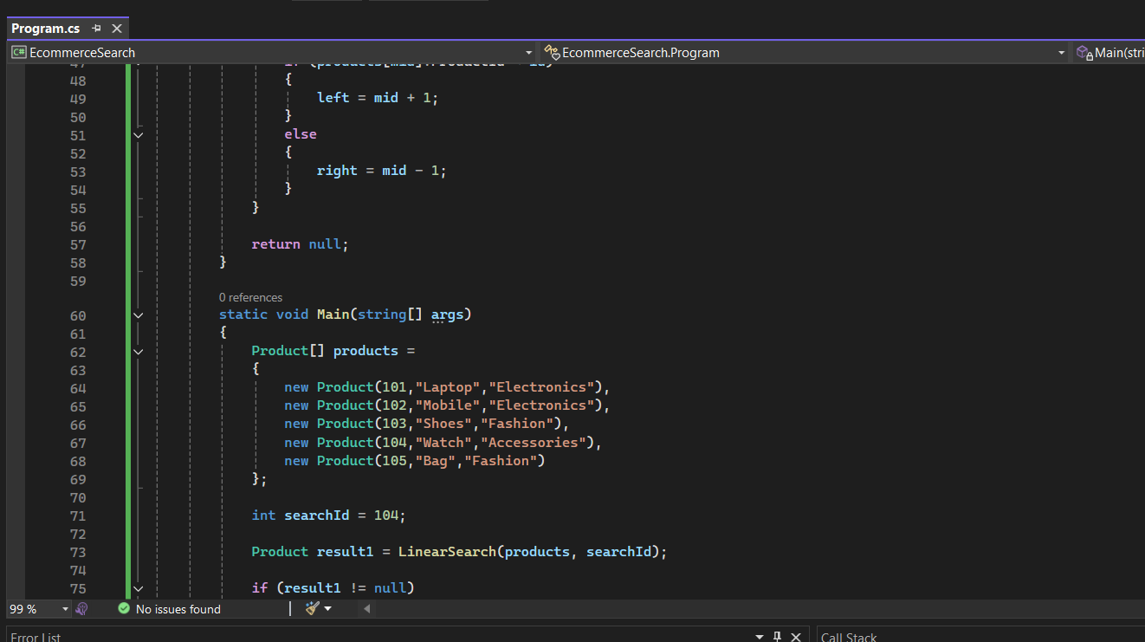
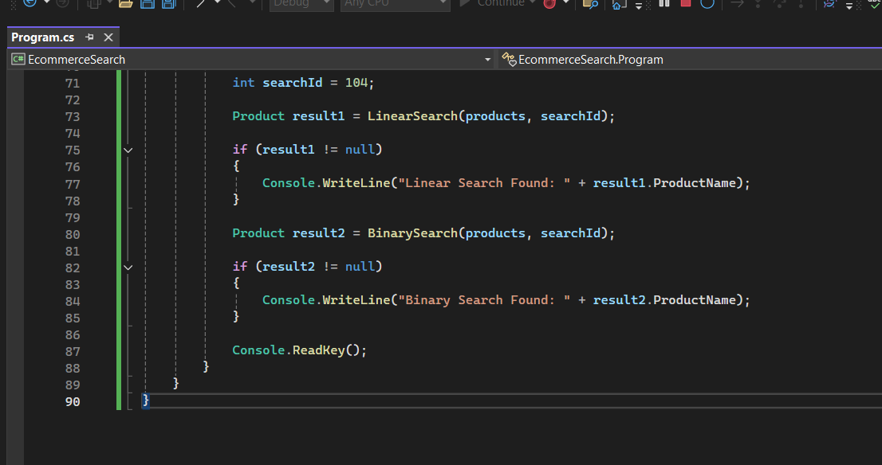

OUTPUT:
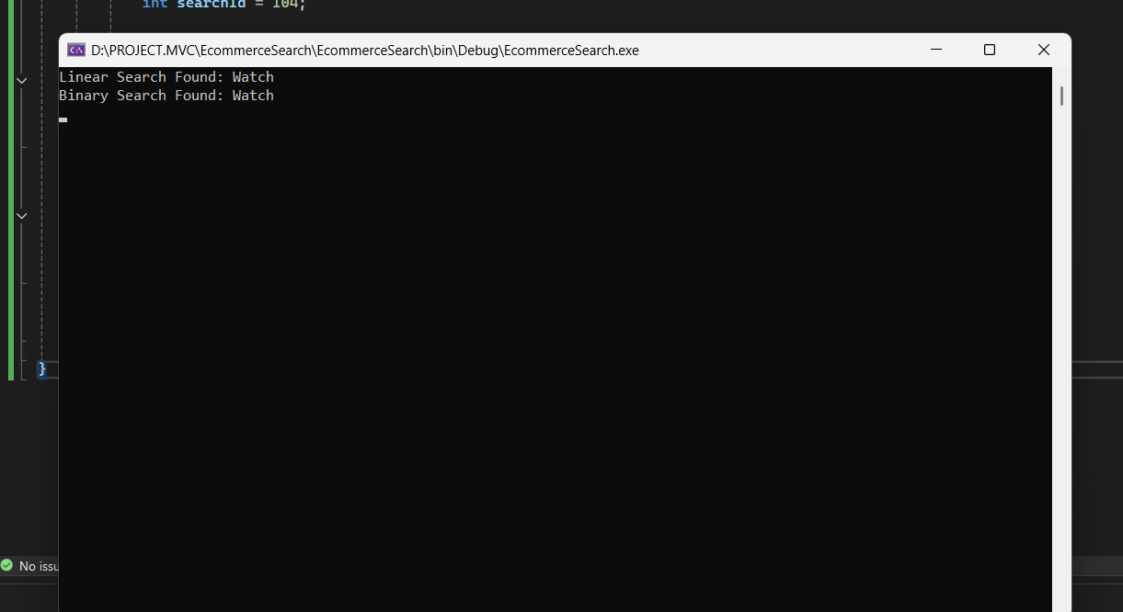
->Which algorithm is more suitable for the e-commerce platform and why?
Binary Search is more suitable for an e-commerce platform because it is much faster than Linear Search when dealing with a large number of products.
- Linear Search checks each product one by one, so its time complexity is O(n).
- Binary Search repeatedly divides the search space into half, so its time complexity is O(log n).
For example, if there are 10,000 products:
- Linear Search may need to check up to 10,000 products.
- Binary Search can find a product in about 14 comparisons.
Therefore, Binary Search provides:
- Faster search performance.
- Better user experience with quicker results.
- Improved efficiency for large product databases.
Conclusion:
For an e-commerce platform where products are stored in a sorted list, Binary Search is the preferred

EXERCISE-7: Financial Forecasting
->What is Recursion?
-Recursion is a technique where a method calls itself to solve a problem.
-A recursive function has:
- Base Case → Stops the recursion.
- Recursive Case → Calls itself with a smaller problem.
CODE:
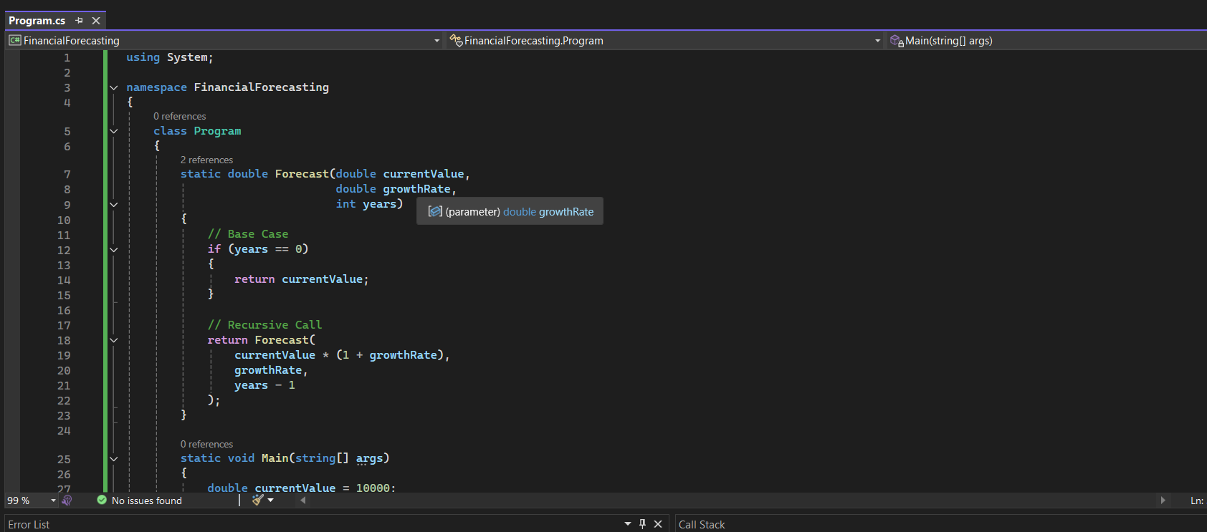
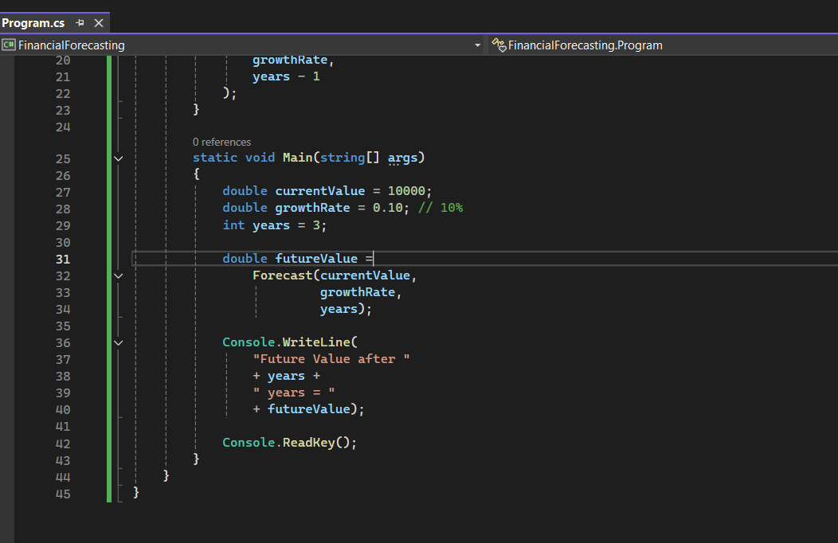

OUTPUT:
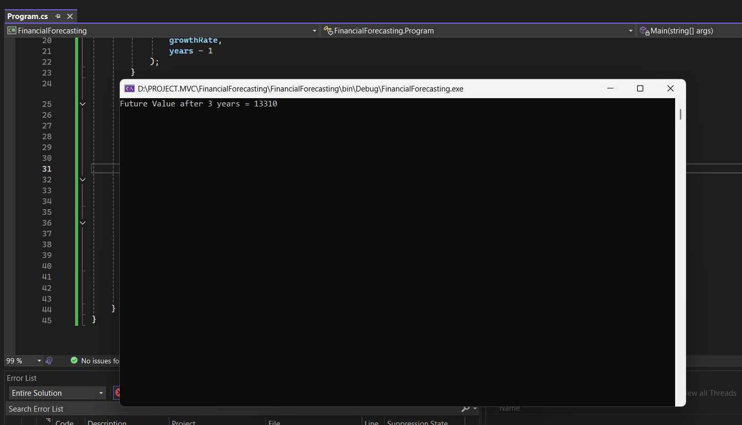

->Analysis
Time Complexity
For each year, one recursive call is made.
T(n) = T(n-1) + 1
Therefore:
Time Complexity = O(n)
Where:
n = number of years

Space Complexity
Because each recursive call stays in memory until completion:
Space Complexity = O(n)
->Optimization of Recursive Financial Forecasting
-Problem with Recursive Approach
The recursive forecasting algorithm works by repeatedly calling itself until the specified number of years reaches zero. While recursion makes the code simple and easy to understand, it creates a new function call for every year being forecasted.
For example:
Forecast(10000, 0.10, 1000)
This results in 1000 recursive function calls being stored in memory. As the number of recursive calls increases, the program consumes more stack memory and may eventually cause a Stack Overflow Exception. Therefore, recursion is not the most efficient solution for large forecasting periods.

Optimization 1: Iterative Approach
An iterative solution uses a loop instead of recursive function calls. The future value is calculated by repeatedly applying the growth rate inside a for loop.
Advantages:
- Does not create multiple function calls.
- Uses less memory.
- More efficient for large inputs.
- Easier to manage and debug.
Complexity Analysis:
- Time Complexity: O(n), because the loop executes once for each year.
- Space Complexity: O(1), because no additional stack memory is required.
The iterative approach is more memory-efficient than recursion while producing the same result.

Advanced SQL Exercises :
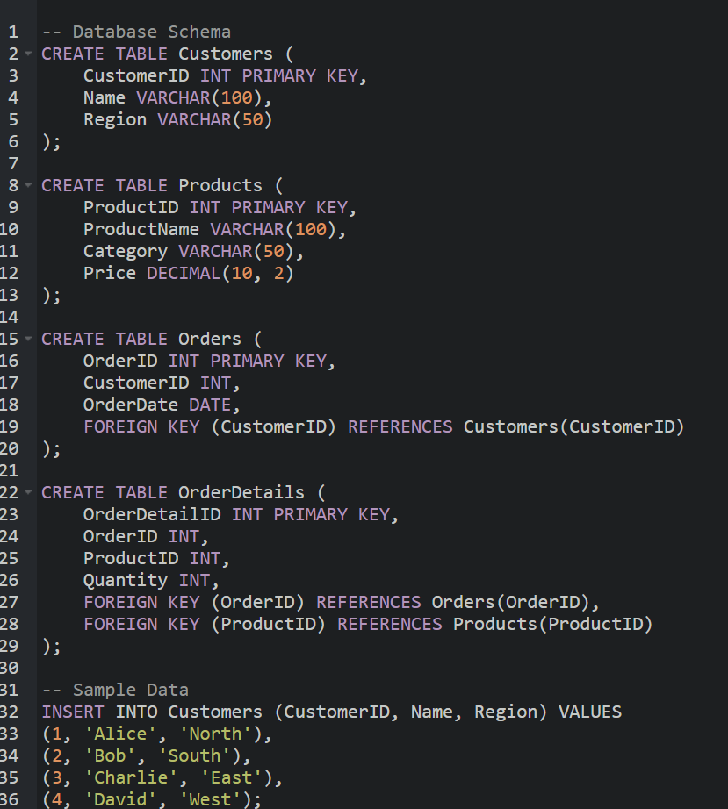
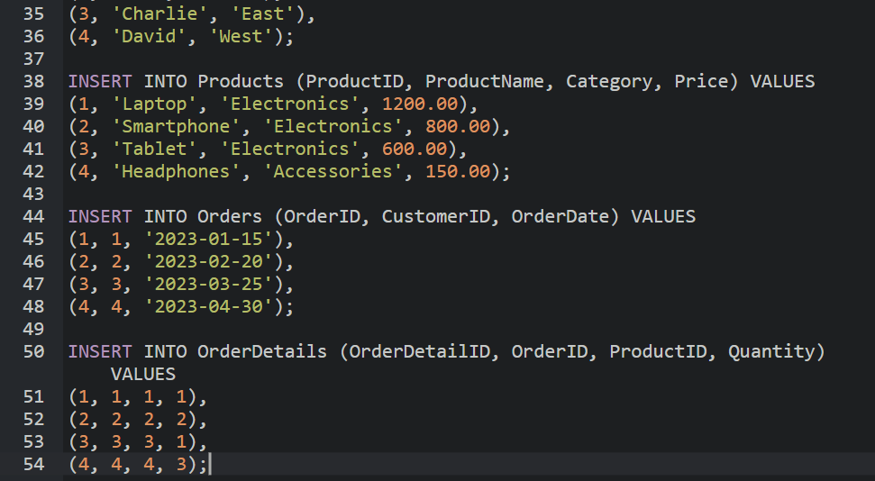

Queries sql:
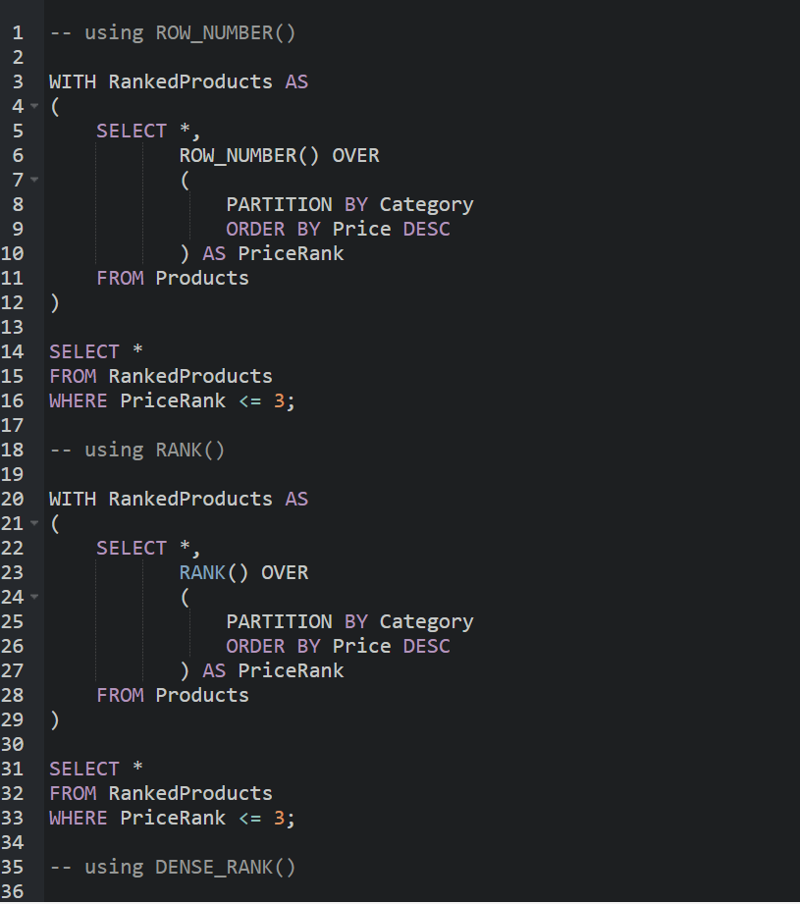
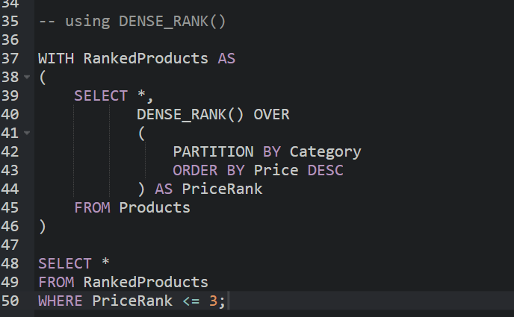\

Output:
Output1:

Output2:

Output3:


NUnit and Moq:
Moq-Handson:
1.CustomerComm.Tests:-
CustomerComm.Tests.csproj code:
﻿<Project Sdk="Microsoft.NET.Sdk">
<PropertyGroup>
<TargetFramework>net10.0</TargetFramework>
<LangVersion>latest</LangVersion>
<ImplicitUsings>enable</ImplicitUsings>
<Nullable>enable</Nullable>
<IsPackable>false</IsPackable>
</PropertyGroup>
<ItemGroup>
<PackageReference Include="coverlet.collector" Version="6.0.4" />
<PackageReference Include="Microsoft.NET.Test.Sdk" Version="17.14.0" />
<PackageReference Include="Moq" Version="4.20.72" />
<PackageReference Include="NUnit" Version="4.3.2" />
<PackageReference Include="NUnit.Analyzers" Version="4.7.0" />
<PackageReference Include="NUnit3TestAdapter" Version="5.0.0" />
</ItemGroup>
<ItemGroup>
<Using Include="NUnit.Framework" />
</ItemGroup>
<ItemGroup>
<ProjectReference Include="..\CustomerCommLib\CustomerCommLib.csproj" />
</ItemGroup>
</Project>
CustomerCommTests.cs code:
﻿using CustomerCommLib;
using Moq;
using NUnit.Framework;

namespace CustomerComm.Tests
{
[TestFixture]
public class CustomerCommTests
{
private Mock<IMailSender> mockMailSender;
private CustomerCommLib.CustomerComm customerComm;
[OneTimeSetUp]
public void Setup()
{
mockMailSender =
new Mock<IMailSender>();
customerComm =
new CustomerCommLib.CustomerComm(
mockMailSender.Object);
}
[TestCase]
public void SendMailToCustomer_ShouldReturnTrue()
{
mockMailSender
.Setup(m =>
m.SendMail(
It.IsAny<string>(),
It.IsAny<string>()))
.Returns(true);
bool result =
customerComm.SendMailToCustomer();
Assert.That(result,
Is.True);
}
}
}

2.CustomerCommLib:
CustomerComm.cs code:
namespace CustomerCommLib
{
public class CustomerComm
{
private readonly IMailSender mailSender;
public CustomerComm(IMailSender mailSender)
{
this.mailSender = mailSender;
}
public bool SendMailToCustomer()
{
string email = "cust123@abc.com";
string message = "Some Message";
mailSender.SendMail(email, message);
return true;
}
}
}
CustomerCommLib.csproj code:
﻿<Project Sdk="Microsoft.NET.Sdk">
<PropertyGroup>
<TargetFramework>net10.0</TargetFramework>
<ImplicitUsings>enable</ImplicitUsings>
<Nullable>enable</Nullable>
</PropertyGroup>
</Project>
IMailSender.cs code:
﻿namespace CustomerCommLib;
public interface IMailSender
{bool SendMail(string toAddress, string message);}
MailSender.cs code:
using System.Net;
using System.Net.Mail;
namespace CustomerCommLib;
public class MailSender : IMailSender
{
public bool SendMail(string toAddress, string message)
{
MailMessage mail = new();
SmtpClient smtp = new("smtp.gmail.com");
mail.From = new MailAddress("your_email@gmail.com");
mail.To.Add(toAddress);
mail.Subject = "Test Mail";
mail.Body = message;
smtp.Port = 587;
smtp.Credentials =
new NetworkCredential(
"username",
"password");
smtp.EnableSsl = true;
smtp.Send(mail);
return true;
}
}
CustomerCommSolution.slnx code:
<Solution>
<Project Path="CustomerComm.Tests/CustomerComm.Tests.csproj" Id="e4eb8d75-0a73-40ed-881f-7a88357fae0f" />
<Project Path="CustomerCommLib/CustomerCommLib.csproj" />
</Solution>

Output:
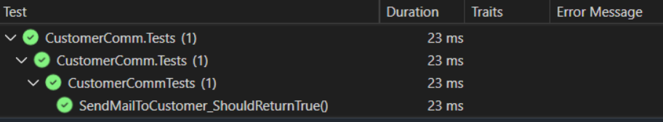
NUnit-Handson:
CalcLibrary.Tests
CalcLibrary.Tests.csproj code:
﻿<Project Sdk="Microsoft.NET.Sdk">
<PropertyGroup>
<TargetFramework>net10.0</TargetFramework>
<LangVersion>latest</LangVersion>
<ImplicitUsings>enable</ImplicitUsings>
<Nullable>enable</Nullable>
<IsPackable>false</IsPackable>
</PropertyGroup>
<ItemGroup>
<PackageReference Include="coverlet.collector" Version="6.0.4" />
<PackageReference Include="Microsoft.NET.Test.Sdk" Version="17.14.0" />
<PackageReference Include="NUnit" Version="4.3.2" />
<PackageReference Include="NUnit.Analyzers" Version="4.7.0" />
<PackageReference Include="NUnit3TestAdapter" Version="5.0.0" />
</ItemGroup>
<ItemGroup>
<Using Include="NUnit.Framework" />
</ItemGroup>
<ItemGroup>
<ProjectReference Include="..\CalcLibrary\CalcLibrary.csproj" />
</ItemGroup>
</Project>

CalculatorTests.csn code
﻿using NUnit.Framework;
using CalcLibrary;
using System;
namespace CalcLibrary.Tests
{
[TestFixture]
public class CalculatorTests
{
private SimpleCalculator calculator;
// Runs before every test
[SetUp]
public void Setup()
{
calculator = new SimpleCalculator();
}
// Runs after every test
[TearDown]
public void Cleanup()
{
calculator.AllClear();
}
// ---------------- Addition ----------------
[Test]
public void Addition_ShouldReturnCorrectSum()
{
double result = calculator.Addition(10, 20);
Assert.That(result, Is.EqualTo(30));
}
[TestCase(10, 20, 30)]
[TestCase(15, 25, 40)]
[TestCase(-5, 5, 0)]
[TestCase(2.5, 3.5, 6)]
public void Addition_TestCases(double a, double b, double expected)
{
double result = calculator.Addition(a, b);
Assert.That(result, Is.EqualTo(expected));
}
// ---------------- Subtraction ----------------
[TestCase(20, 10, 10)]
[TestCase(5, 10, -5)]
[TestCase(-5, -5, 0)]
public void Subtraction_TestCases(double a, double b, double expected)
{
double result = calculator.Subtraction(a, b);
Assert.That(result, Is.EqualTo(expected));
}
// ---------------- Multiplication ----------------
[TestCase(10, 5, 50)]
[TestCase(-5, 2, -10)]
[TestCase(0, 100, 0)]
public void Multiplication_TestCases(double a, double b, double expected)
{
double result = calculator.Multiplication(a, b);
Assert.That(result, Is.EqualTo(expected));
}
// ---------------- Division ----------------
[TestCase(20, 5, 4)]
[TestCase(15, 3, 5)]
[TestCase(-10, 2, -5)]
public void Division_TestCases(double a, double b, double expected)
{
double result = calculator.Division(a, b);
Assert.That(result, Is.EqualTo(expected));
}
// ---------------- Exception Test ----------------
[Test]
public void Division_ByZero_ShouldThrowArgumentException()
{
Assert.That(() => calculator.Division(10, 0),
Throws.TypeOf<ArgumentException>()
.With.Message.EqualTo("Second Parameter Can't be Zero"));
}
// ---------------- Property Test ----------------
[Test]
public void GetResult_ShouldReturnLastCalculatedValue()
{
calculator.Addition(10, 5);
Assert.That(calculator.GetResult, Is.EqualTo(15));
}
// ---------------- AllClear Test ----------------
[Test]
public void AllClear_ShouldResetResultToZero()
{
calculator.Addition(10, 5);
calculator.AllClear();
Assert.That(calculator.GetResult, Is.EqualTo(0));
}
// ---------------- Ignore Example ----------------
[Test]
[Ignore("Example of Ignore attribute.")]
public void Ignored_Test()
{
Assert.Fail();
}
}
}

CalcLibrary
CalcLibrary.csproj code:
<Project Sdk="Microsoft.NET.Sdk"
<PropertyGroup>
<TargetFramework>netstandard2.0</TargetFramework>
</PropertyGroup>
</Project>
MathLibrary.cs code:
﻿using System;
namespace CalcLibrary
{
interface IMathLibrary
{
double Addition(double a, double b);
double Subtraction(double a, double b);
double Multiplication(double a, double b);
double Division(double a, double b);
}
public class SimpleCalculator : IMathLibrary
{
double result = 0;
public double Addition(double a, double b)
{
result = a + b;
return result;
}
public double Subtraction(double a, double b)
{
result = a - b;
return result;
}
public double Multiplication(double a, double b)
{
result = a * b;
return result;

public double Division(double a, double b)
{
if (b == 0)
throw new ArgumentException("Second Parameter Can't be Zero");
result = a / b;
return result;
}
public void AllClear()
{
result = 0;

public double GetResult
{
get { return result; }
}
}
}
CalcLibrary.sln code:
Microsoft Visual Studio Solution File, Format Version 12.00
# Visual Studio Version 18
VisualStudioVersion = 18.7.11911.148 stable
MinimumVisualStudioVersion = 10.0.40219.1
Project("{9A19103F-16F7-4668-BE54-9A1E7A4F7556}") = "CalcLibrary", "CalcLibrary\CalcLibrary.csproj", "{CF9F0ABE-C280-4F84-8890-69F9E59BF84F}"
EndProject
Project("{FAE04EC0-301F-11D3-BF4B-00C04F79EFBC}") = "CalcLibrary.Tests", "CalcLibrary.Tests\CalcLibrary.Tests.csproj", "{9523897D-DE7F-45F1-B27B-8F3C25A43869}"
EndProject
Global
GlobalSection(SolutionConfigurationPlatforms) = preSolution
Debug|Any CPU = Debug|Any CPU
Release|Any CPU = Release|Any CPU
EndGlobalSection
GlobalSection(ProjectConfigurationPlatforms) = postSolution
{CF9F0ABE-C280-4F84-8890-69F9E59BF84F}.Debug|Any CPU.ActiveCfg = Debug|Any CPU
{CF9F0ABE-C280-4F84-8890-69F9E59BF84F}.Debug|Any CPU.Build.0 = Debug|Any CPU
{CF9F0ABE-C280-4F84-8890-69F9E59BF84F}.Release|Any CPU.ActiveCfg = Release|Any CPU
{CF9F0ABE-C280-4F84-8890-69F9E59BF84F}.Release|Any CPU.Build.0 = Release|Any CPU
{9523897D-DE7F-45F1-B27B-8F3C25A43869}.Debug|Any CPU.ActiveCfg = Debug|Any CPU
{9523897D-DE7F-45F1-B27B-8F3C25A43869}.Debug|Any CPU.Build.0 = Debug|Any CPU
{9523897D-DE7F-45F1-B27B-8F3C25A43869}.Release|Any CPU.ActiveCfg = Release|Any CPU
{9523897D-DE7F-45F1-B27B-8F3C25A43869}.Release|Any CPU.Build.0 = Release|Any CPU
EndGlobalSection
GlobalSection(SolutionProperties) = preSolution
HideSolutionNode = FALSE
EndGlobalSection
GlobalSection(ExtensibilityGlobals) = postSolution
SolutionGuid = {81769E1B-3B70-4325-8C22-988EF210FE89}
EndGlobalSection
EndGlobal
Output:
